CyberLabs Winter of Code (WoC)

Machine Learning Models – From Scratch Implementation

Project Report By :- Parth Patil

Introduction :-
This report documents my work for the CyberLabs Winter of Code (WoC) Machine Learning track, with a strict focus on implementing fundamental ML algorithms entirely from scratch using only NumPy, Pandas, and Matplotlib. No high-level machine learning libraries such as scikit-learn, TensorFlow, or PyTorch were used.
The primary objective of this project was not just to achieve high performance, but to develop a deep mathematical and algorithmic understanding of how machine learning models work internally. Emphasis was placed on loss functions, optimization through gradient descent, numerical stability, and the effect of design choices such as initialization, normalization, and evaluation metrics.
Linear Regression:-
● It is a supervised Machine Learning algorithm
● Used when the data is linear and a straight line can fit the model well

Dataset & Preprocessing
The dataset contains numerical input features and a continuous target variable. Missing values were handled using mean imputation. The data was randomly split into 80% training and 20% validation to evaluate generalization performance.

Exploratory Data Analysis (EDA)
A histogram of the target variable was plotted to understand its distribution. The distribution indicated that Mean Squared Error (MSE) is an appropriate loss function.
Additionally, the distribution of a representative feature was visualized before normalization. Large variation in feature scale was observed, motivating the need for normalization to ensure stable gradient descent.

Formulas used :
Cost :-
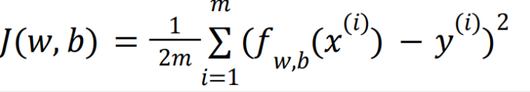
Gradient :- 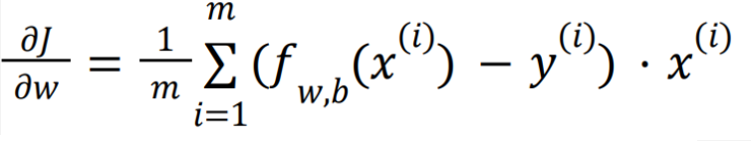
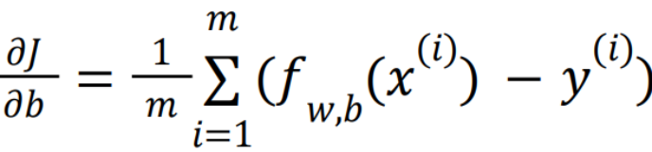
Graphs :-

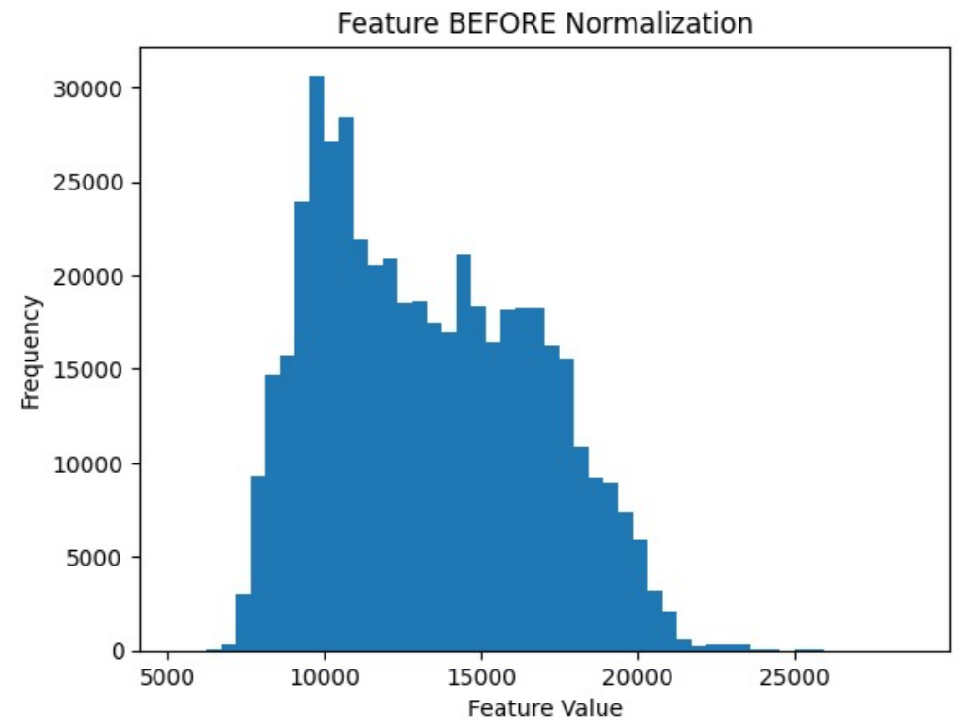
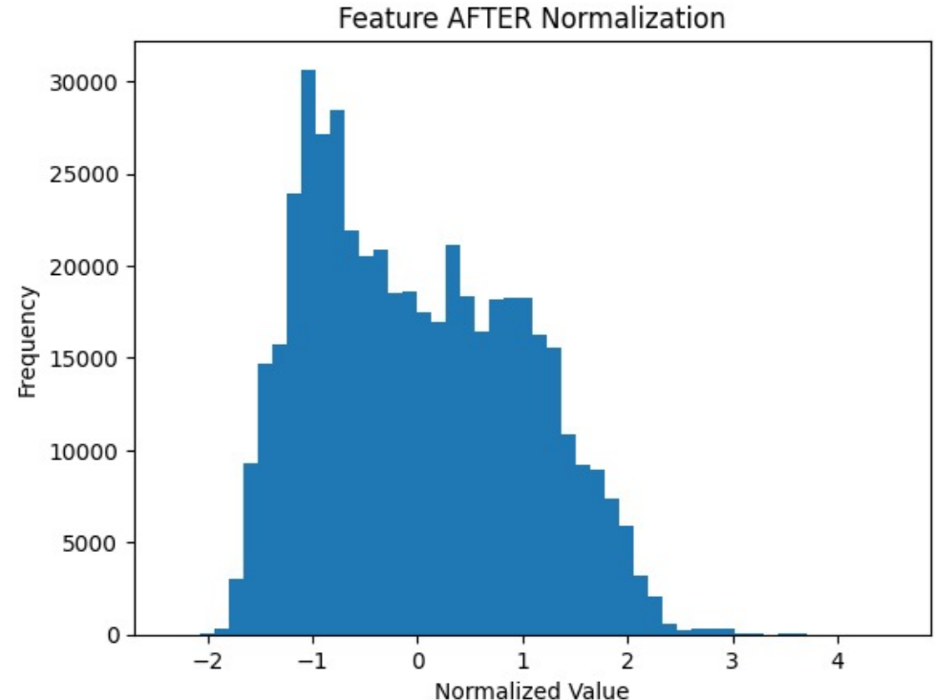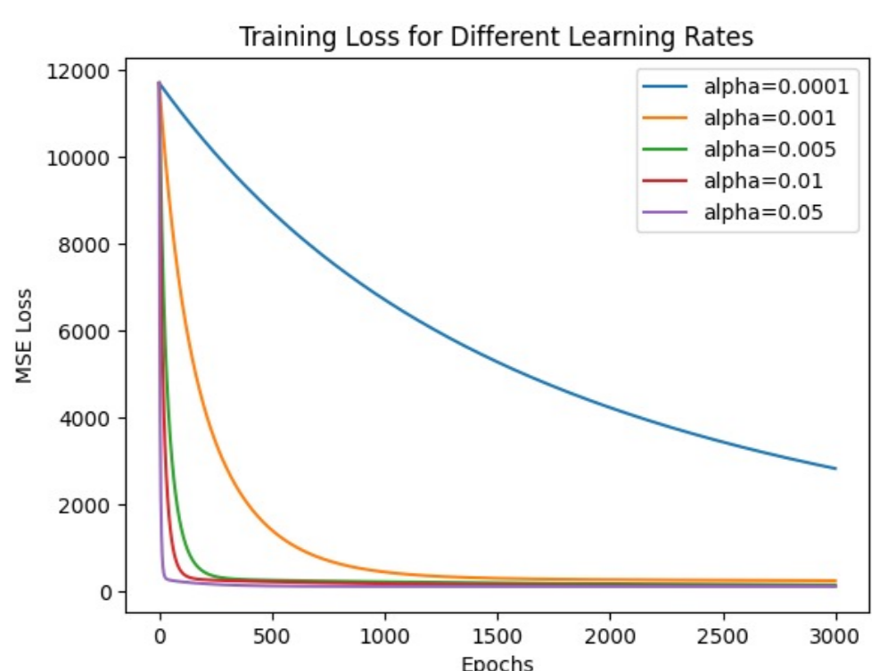
Hyperparameter
Learning rate :- 0.05

Experiments in implementations :-
Firstly I was trying various values for alpha then I got to know about alpha tuning then I observed different convergence behaviours in the loss curves, so I evaluated multiple α values and selected the one that minimized validation error.

LOGISTIC REGRESSION :-
● It is a supervised Machine Learning algorithm
● Used for classification using logistic(sigmoid) function
● For multiclass classification one vs rest method can be used

Formulas used :-

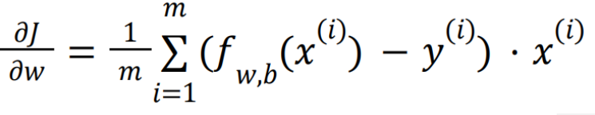
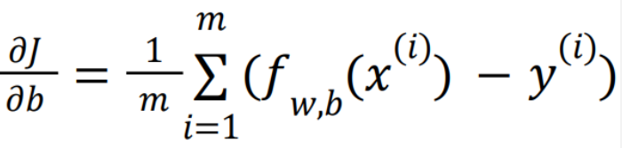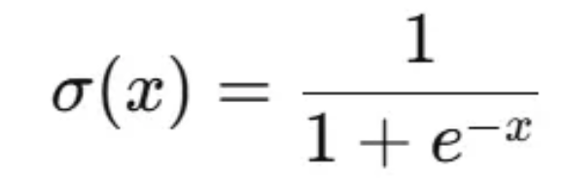
LOSS :-
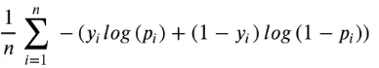
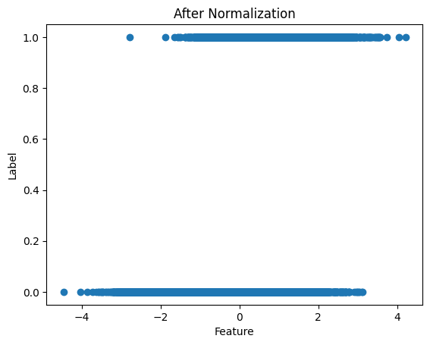
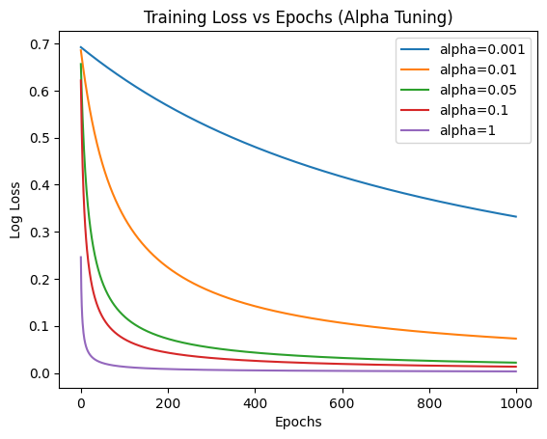Optimum alpha from learning rate tuning :- 1
Train Accuracy: 0.9994 Val Accuracy : 0.9997
Extra Implementations :-
Confusion Matrix (Validation)
TP: 3032 FP: 0 FN: 3 TN: 6965
Accuracy alone can be misleading, especially in binary classification.
Therefore, a confusion matrix was computed to analyze class-wise performance by explicitly measuring true positives, true negatives, false positives, and false negatives.
This provided deeper insight into model behavior and helped verify that the classifier achieved both high precision and high recall, rather than simply optimizing for overall accuracy.
POLYNOMIAL REGRESSION :-
● It is a supervised Machine Learning algorithm
● Used when the data is non linear and a polynomial function can fit the model well
Calculations :-
Cost :-
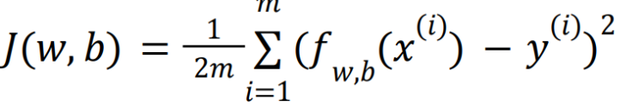
Gradients :-
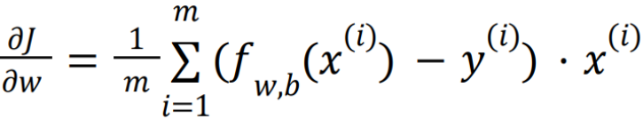
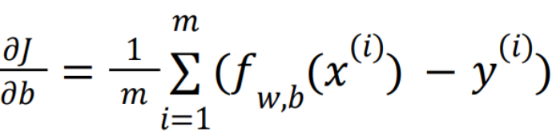
In this graphs were plot to see feature relation and features were selected accordingly at the same time ensuring validation accuracy dosent fall…. In our case, x3, x6, and x7 and other in graph individually show weak or noisy influence, and no evidence suggests their joint interaction improves predictability. Adding such terms would increase variance without reducing bias.”
For example
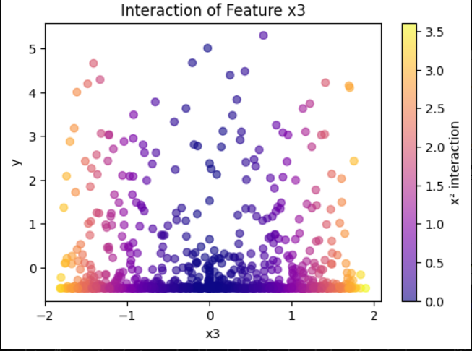

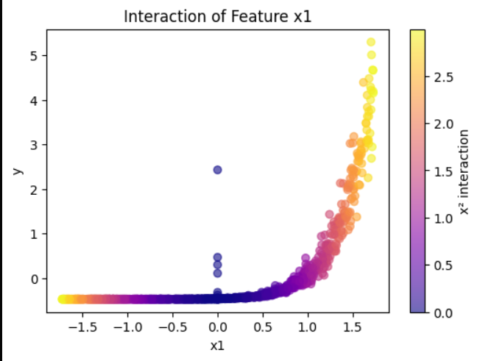

The below graphs shows how some features negatively affect ;-
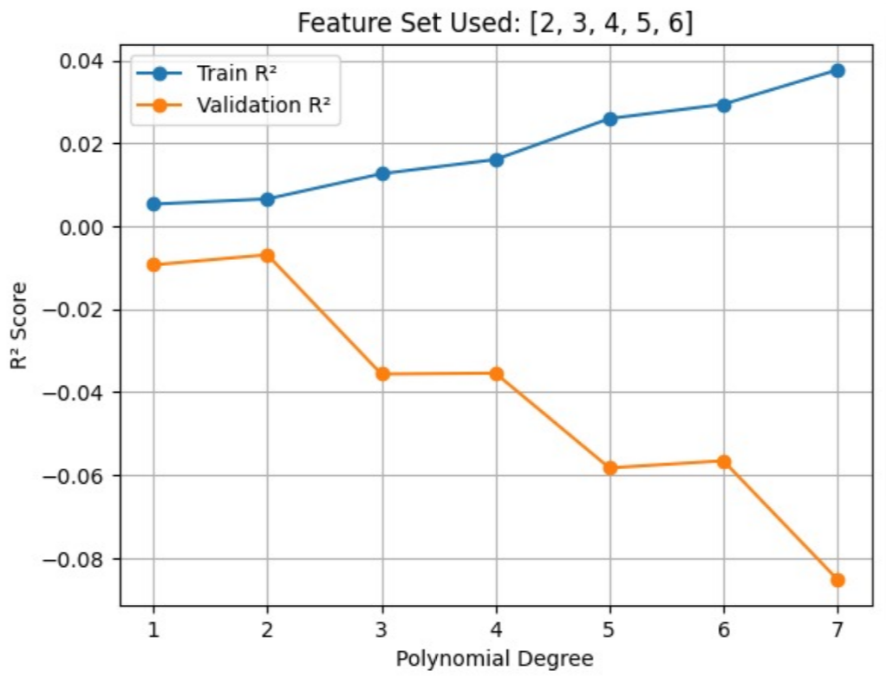
x1 shows a strong, monotonic non-linear relationship with the target, where higher-order polynomial terms directly drive predictions and significantly reduce model bias.
x3, in contrast, exhibits a weak, symmetric, and non-directional relationship with the target, where polynomial expansion adds little predictive power and mainly increases variance.
Best Polynomial Degree: 9
Train Accuracy (R²): 0.9965
Validation Accuracy (R²): 0.9963
K means
● It is a unsupervised Machine Learning algorithm
● Used to divide a dataset into K clusters

Hyperparameter : K=5 using the elbow method
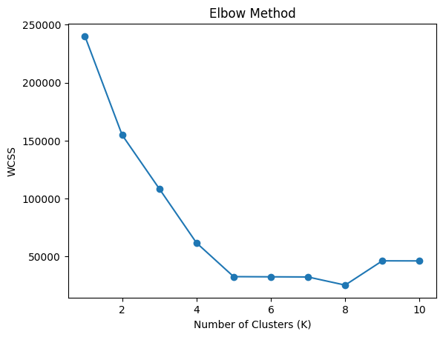
KNN
● It is a supervised Machine Learning algorithm
● Used to classify the data using the euclidean distance formula ● It can also be used for regression
In this model to increase speed :-
No loop method :-
I sped up the KNN algorithm by removing slow Python loops and replacing them with fast NumPy operations. Instead of calculating distances one by one, we used a neat math trick: $\left(a-b)^{2}=a^{2}+b^{2}-2ab\right.$, which lets us compute all pairwise distances in a single matrix multiplication. Majority voting was also vectorized using np.bincount, so predictions happen in bulk
Neural Network :-
● Inspired by biological neural networks in the human brain
Important graphs :-
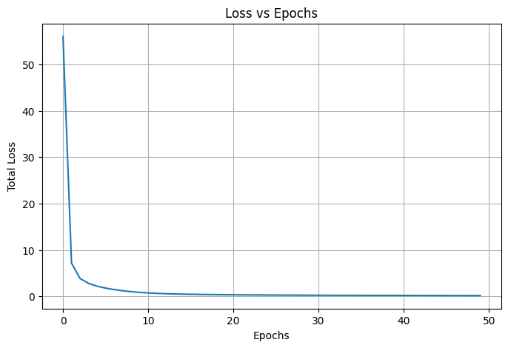
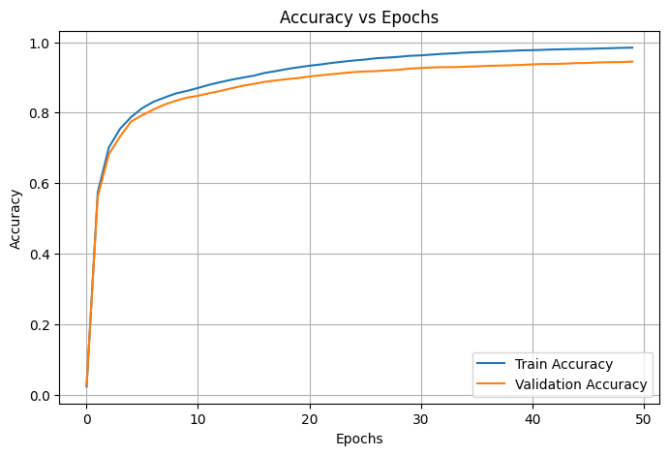
Hyperparameters:-
lr = 0.001
weight_decay = 1e-4
beta1, beta2, eps = 0.9, 0.999, 1e-8
epochs = 5000
some observation points from experimentation and learnings:-

During experimentation, we observed that directly applying the softmax function on raw logits could lead to numerical instability due to large exponential values. To address this, we subtract the maximum logit value from each sample before computing softmax. This stabilizes the exponential computation and prevents overflow issues during training. Since softmax is invariant to constant shifts, this adjustment does not affect the final class probabilities but makes the training process more stable and reliable.
IN this …………..
def softmax(z):
z -= np.max(z, axis=1, keepdims=True)
return np.exp(z) / np.sum(np.exp(z), axis=1, keepdims=True)

And I chosed Relu because :-
The ReLU gradient is computed as 1 for positive inputs and 0 for non-positive inputs.
This allows gradients to flow only through neurons that were active during the forward pass.
Inactive neurons block gradient flow, leading to sparse and efficient updates.
This behavior helps reduce vanishing gradients and improves training stability.

ADAM OPTIMIZER :-
During training, we initially experimented with basic gradient descent and observed slow convergence and unstable updates. To overcome this, we used the Adam optimizer, which combines momentum and adaptive learning rates for each parameter. Adam maintains moving averages of both the gradients and their squared values, allowing it to make more informed and stable updates. This resulted in faster convergence and more consistent training behavior across epochs.

Some more points :-
I implemented a multi-task neural network completely from scratch using NumPy to jointly handle classification and regression.

I experimented with different loss setups and observed that using class-weighted cross-entropy significantly improved performance on minority classes.

Adding L2 regularization and switching to the Adam optimizer helped stabilize training and reduced overfitting over long epochs.

The shared hidden representation improved regression performance while maintaining strong classification accuracy.

This project helped me deeply understand backpropagation, optimizer dynamics, and practical model design trade-offs.

Bias variance trade offs were made by analyzing graphs of train and cross validation accuracy

Kaggle Submission
Logistic regression (best of 2)
Pvt leaderboard rank :- 6 th
Logistic Regression – Implementation & Observations
The Logistic Regression model was implemented entirely from scratch using NumPy, without using any external machine learning libraries. The model applies the sigmoid activation function to the linear combination of inputs to obtain probability estimates, which are then used for binary classification.
Model parameters were trained using Gradient Descent, with Binary Cross-Entropy (log loss) as the objective function. A classification threshold of 0.5 was chosen after validation, as it provided a good balance between false positives and false negatives. The learning rate was not fixed initially; instead, it was experimentally tuned to achieve smooth and stable convergence, avoiding divergence and oscillations during training.
To address overfitting, L2 regularization was incorporated into the loss function. In early Kaggle submissions, the model showed high training accuracy but inconsistent leaderboard performance, indicating poor generalization. Adding regularization helped control large weights and improved the model’s performance on unseen data.
For evaluation, accuracy alone was not considered sufficient. Therefore, the confusion matrix was analyzed to better understand the distribution of true positives, false positives, false negatives, and true negatives. Additionally, the precision–recall trade-off was examined to validate the chosen probability threshold. The final Kaggle submission was generated using the best validation-performing model, rather than simply using the weights from the last training epoch.
Overall, Logistic Regression performed well on approximately linearly separable data, serving as a strong baseline model. The inclusion of regularization played a crucial role in improving generalization and achieving more stable results on the Kaggle test set.
Balanced accuracy :- 0.66

OVERALL LEARNINGS :-
Learned why we split data into three parts:
● Training set - used to train the model
● Cross validation set - used to evaluate whether the model is overfitting or not.
● Test set - used to give a fair estimate of your chosen model's performance against new examples.

Also I learnt about randomization of train data so that model dosent learn any patterns and arrangement in data set

Vectorization really helped imporving speed ………………

Personal Details
- Name : Parth Patil
- Admission No : 25JE0284
- Phone No. : 9350114220
- Email :- 25je0284@iitism@ac.in
- Github profile : Parth-ui-commits

Why should I be selected ?
I am interested in Machine Learning and want to pursue it as a career path.
I have developed this interest through workshops and seeing videos also Kaggle competition and Winter Of Code enhanced mu interest further. Being part of Cyberlabs will allow me to explore this field deeper. I believe that my interest in coding and a growing curiosity about AI makes me a suitable candidate for this project.

